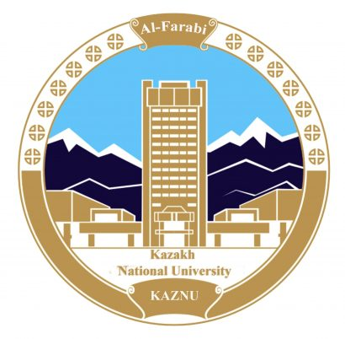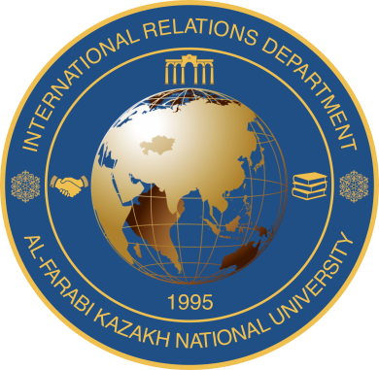

Al-Farabi Kazakh National University
Faculty of International Relations
Diplomatic Translation Department

Dear Colleagues!

Diplomatic Translation Department and the International Centre for Intercultural Communication and Translation Research of the Faculty of International Relations is pleased to invite you to participate in an online International Scientific and Methodological Seminar «Internationalization of Education: Contemporary Methods of Teaching Foreign Languages for Specific Purposes» which will be held on January 22, 2021.
The purpose of the seminar is to create an information and discussion platform on the theoretical and applied aspects of teaching foreign languages, internationalization of higher education, online learning as well as to improve the process of teaching foreign languages.
Leading foreign and domestic scientists, specialists working in the field of language and intercultural education and linguistics have been invited to participate in the seminar.

Plenary Speakers:
- Professor А. Аkkari – University of Geneva (Switzerland)
- Professor Seb Berny- University of Birmingham (UK)
- Julie Duperoir - Head of Pedagogy Hachette FLE, France
- Dr. Naima Ahmad Husban - Arab Open University, Jordan
- Karimova Zulfizar Rustamovna - affiliated branch of Lomonosov Moscow State University, Tashkent, Uzbekistan.
- Rakhimova Gulsanam Ashirbekovna, Associate Professor, Mirzo Ulugbek National University of Uzbekistan
- Kesler Thorsten -Lecturer DAAD, Germany.
- Seidikenova Almash, Ph.D, Professor, Al-Farabi Kazakh National University, Kazakhstan
- Bakitov Aitkali, Ph.D, Associate Professor, Al-Farabi Kazakh National University, Kazakhstan.

The seminar will be held on January 22, 2021 14.00 - 18.00-French section, 16.00 -20.00-English section. (Nur-Sultan time, Kazakhstan).
Within the framework of the seminar 2 sections are planned:
1. Topical Methods of Teaching the French Language for Special and Academic Purposes
2. The Role of Foreign Languages in the Process of Internationalization of Higher Education
Applications for participation as well as articles are accepted until January 18, 2021. Application form for participation with a report or for attendance as a listener at the link:
https://docs.google.com/forms/d/e/1FAIpQLSffNWgiQMGzGBQlGI7No6rqmqwXq2BAmnZ_cGzNp9kX6CEObA/viewform?usp=sf_link
or at the address: Almaty, Karasay Batyr str. 95a, Faculty of International Relations, Department of Diplomatic Translation, office 203.

Application rules: materials are accepted – in English and French with annotations:
- the maximum volume of the report (article) is 6-7 pages, without annotation and literature;
- A4 format; Times New Roman; size-12;
- single -spaced;
- page margins of 2.00 cm;
- width alignment;
- text without hyphenation;
- at the end of the text, the list of references of the text is placed.
- resume of at least 150 words in English, Kazakh and Russian.
Design of the first page of the article:
Title of the article (size 12, bold);
Author's surname and initials; place of work/study; position;
Abstract-in three languages required (English, Kazakh and Russian)
Next, from the red line, the text.

Abstracts (at least 150 words) or articles should be sent in electronic form to the conference email address: aitkali.bakitov@kaznu.kz ; Aigerim.aktas@kaznu.kz

Abstracts will be evaluated in accordance with the originality of the topic, a clear methodology and theoretical basis as well as the scientific contribution of the research.
The materials of the seminar will be published in a special collection book. Applications submitted after the specified deadline will not be accepted. The decision of the organizing committee to include the report in the seminar program will be communicated by e-mail no later than January 18, 2021.

Venue and format: online, al-Farabi KazNU Faculty of International Relations, Almaty
Links to connect to the online seminar will be sent on January 21, 2021 to all persons who have applied for participation with a report or presence as a listener.
Time: 14: 00-20 :00 (Nur-Sultan time)
Working languages: English, French

Collections of articles and certificates are issued to participants after the seminar during the week.
Conference organizers: Diplomatic Translation Department of Al Farabi KazNU Faculty of International Relations.
Seidikenova A. S., Bakitov A. T., Sagidoldin K., Aktas A.

You may kindly confirm your participation via phone No. + +7073648420
or via e-mail: aitkali.bakitov@kaznu.kz, Aigerim.aktas@kaznu.kz, Kanat.Sagidoldin@kaznu.kz

Best regards,
Organization Committee of the Seminar

